LESSON B4-2:
TOPIC
B3
PROGRAMMING LINKED

LISTS
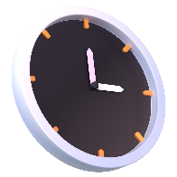
TIME TO COMPLETE: 1 HOUR

WARM UP QUESTION:
Given what we know so far about linked lists, what do you think we’ll need to be programming today?
How many different functions? How would you split it up?

WHAT YOU’LL NEED:
Pycharm

NODE CLASS
Copy/Paste your node class here

LINKED LIST CLASS
Copy/paste your Linked List class here

INSERTION INTO A LINKED LIST
Copy/paste your insertion functions here

DELETION FROM A LINKED LIST
Copy/paste your deletion function here

SEARCHING A LINKED LIST
Copy/paste your search function here

